**[F29DC 2024 Lab 4 –](https://canvas.hw.ac.uk/courses/28951/files/3694381?wrap=1" \o "F29DC 2024 Lab 1 - Connectivity, VPCs, Subnets, VLANs.pdf" \t "_blank) DHCP and NAT  
- Shyam Sundar Velmurugan  
- H00418621**

{Part 3}

NAT

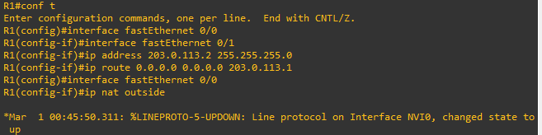

Image 3.1 : Entering configure mode in R1 router and setting up fast ethernet 0/0 and 0/1 with ip address 203.0.113.2 255.255.255.0.  
Then, we provide the ip route 0.0.0.0 0.0.0.0 203.0.113.1 and set up fast Ethernet 0/0 and finally ip nat outside.  
This sets the interface of the router as WAN for 0/1.

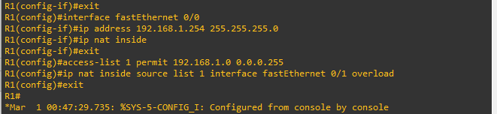

Image 3.2 : For the ip nat inside, exiting the ip nat outside and setting up fast Ethernet 0/0 with ip address 192.168.1.254 255.255.255.0 and exiting.   
This sets the interface of the router as LAN

Then, accessing the list 1 and permitting ip address 192.168.1.0 0.0.0.255.

Finally, we overload the fastEthernet 0/1 and exiting.

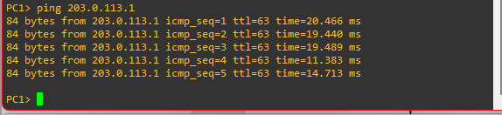

Image 3.3 : Pinging the ip 203.0.113.1 from PC1.

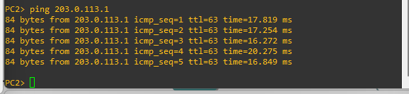

Image 3.4 : Pinging the ip 203.0.113.1 from PC2.

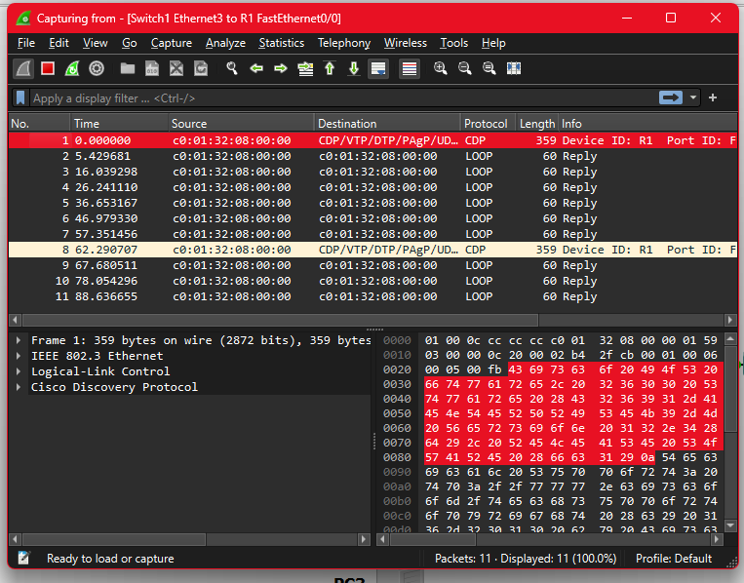

Image 3.5 : Using wireshark on the connection between Switch and R1.

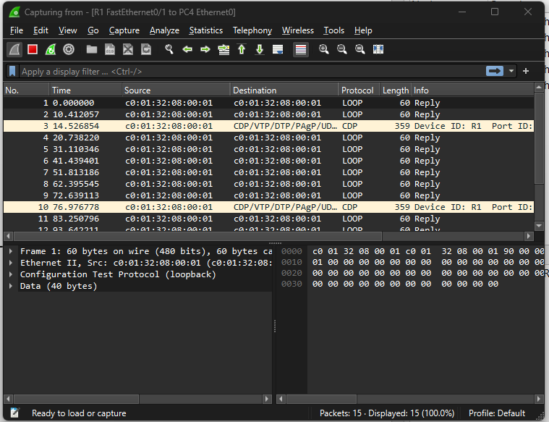

Image 3.6 : Using the wireshark on the connection between R1 and PC4.

------------------------------------------------------------------------------------------------------------------------------------------